PROTEA VILLAGE COMMUNITY LAND CLAIM:
SITE ANALYSIS AND GUIDELINES FOR FUTURE DEVELOPMENT OF ERF 212 AND 242, BISHOPSCOURT

Background
The Protea Village claimant community, represented by the Protea Village Action Committee (Provac), has lodged a claim for restitution of land rights with the Land Claims Commission in terms of the Restitution of Land Rights Act (22 of 1994). The claim has been lodged on behalf of 86 former tenants, who resided in the original Protea Village Area and were forcibly removed during the 1960s, in terms of the Group Areas Act (41 of 1950).

As part of the restitution process, the City of Cape is investigating future potential uses of the properties in question. These are erf 212, erf 242 and a portion of farm 875, in Bishopscourt.

The City of Cape Town's Planning and Environment Directorate (Land Restitution and Other Projects Branch) have appointed Common Ground and NM & Associates to assist in this process. Common Ground are sustainable development consultants. NM & Associates are planners and designers.

This document explains the brief, and the proposed process that will be followed. Opportunities for stakeholder involvement are also set out.

Affected Properties
The Protea Village Land Claim is for the restoration of erven 242 and 212, and a portion of Farm 875: Cecil Rhodes, in Bishopscourt. These properties are shown on the photograph of the site on the next page.

The properties include

- Erf 242 (3.8ha) , which is located to the north of Kirstenbosch Drive and to the east of the three stone cottages that are on Rhodes Drive. This erf is currently owned by the Department of Public Works, and leased by the National Botanical Institute (NBI). According to the Land Claims Commission, the Department of Public Works (and NBI) have agreed to transfer erf 242 to the community, once a legal entity is formed;

- Erf 212, the Boshenheuwel Arboretum (8.6 ha), is located between Kirstenbosch Drive and the Liesbeeck River. This erf is held by the City, and its availability for resettlement will be assessed in terms of the city’s land restitution policy, land usage and amenity value, land rights that were lost and the technical and environmental feasibility of resettlement; and,

- The claimant community is requesting the restoration and use of the Stone Cottages on the affected portion of Farm 875. These are currently used by the NBI and are the subject of an ongoing negotiation between the Land Claims Commission and the NBI.

Research has indicated that the majority of former tenants resided on erf 242, and that erf 212 was primarily a social and recreational area. Tenants had access to, and use of water from the Liesbeeck River (which currently forms the southern boundary of erf 212).

Project brief
The consultants have been appointed to undertake a contextual and site analysis of the properties in question. As part of the process, and in the light of the Protea Village Community land claim, they will also determine guidelines for the development of erf 242, and investigate possible alternative future uses for erf 212.

The study will result in two key reports, as follows:

- A site analysis (‘contextual analysis’) of the area; and,
- The development of broad design guidelines for development of the area, including the preferred location/s and density for resettlement, based on the contextual informants.

The process that will be followed for developing the report s will be based on the anticipated requirements of the National Heritage Resources Act (25 of 1999), for which regulations are expected to be promulgated in the next few months.
.

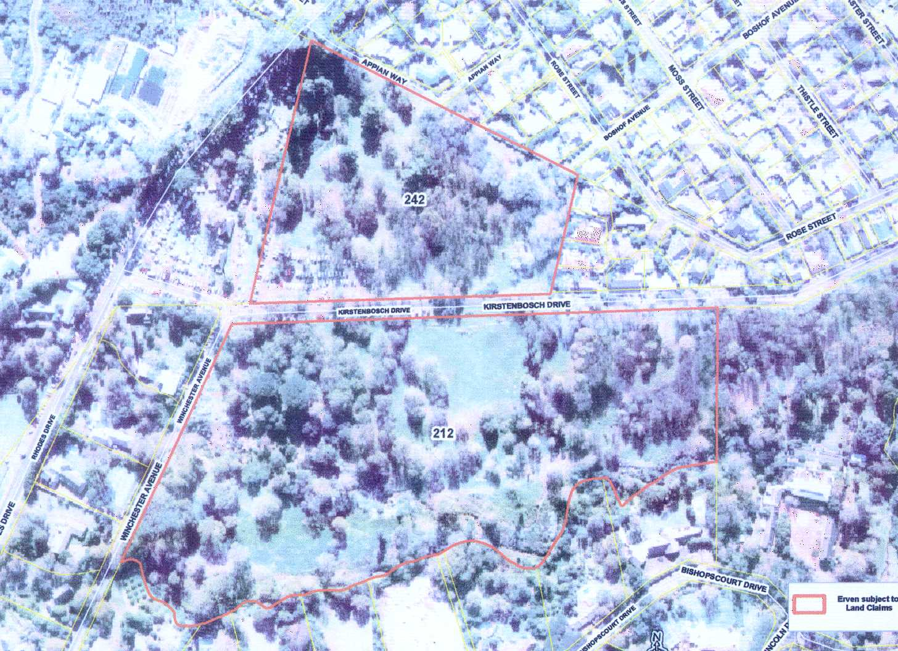
Figure 1: Location of erf 212 and erf 242 Bishopscourt

The reports
As mentioned, two main reports will be produced by the consultants. These are described below.

1. The Contextual Analysis
The contextual analysis of the site will be a summary of information about the site, including:

- The planning framework and policy context;
- An environmental and landscape analysis;
- Cultural and heritage aspects;
- Access and movement;
- Socio-economic factors;
- Bulk infrastructure and service provision;
- Potential inherited risks; and,
- The preliminary cost implications of redeveloping and resettlement.

NM & Associates will co-ordinate the contextual analysis for the area, and, as far as possible, the information will be shown graphically.

2. The broad design guidelines
The Contextual Analysis will inform the preparation of Development Guidelines for erf 242, and the identification of possible alternative uses for erf 212.

These guidelines will propose opportunities for appropriate resettlement, including the location of structures, appropriate densities, and access and transportation.

The guidelines will take the following into account:

- Possible future land uses and related opportunities and constraints
- Impacts that may be associated with development (both positive and negative), and including social, biophysical, cultural, economic and financial impacts

These guidelines will also be co-ordinated by NM & Associates Planners and Designers. As far as possible, these guidelines will also be shown graphically.

The process
The process that is proposed for developing the guidelines has six phases. These are set out in the flow chart below.

Stakeholder involvement is an important part of the process of developing the guidelines. This aspect of the study will be co-ordinated by Common Ground.

There will be three main opportunities for stakeholder involvement. These are:

- Opportunities to comment on the process and assist the project team in identifying information that will inform the site analysis
- Opportunities to comment on the draft site analysis, and provide information for the development of guidelines for development
- Opportunities to comment on the draft guidelines for development

timing
The consultants have been asked to produce their reports by the end of June 2003, and at this stage the public participation events are scheduled to take place in May and June 2003. Please note that these dates are provisional, and may change during the course of the study. We will keep you informed of any changes.

Figure 2: Proposed process

Participation
As mentioned above, Common Ground will facilitate stakeholder involvement in the process. We will be responsible for ensuring that issues, concerns and opportunities that are identified during this process are considered by the project team when they develop the site analysis and guidelines for future development.

We are planning a series of focus group meetings and a public event in this regard, and will let you know the details of these events in due course.

Please let us know if you would like to participate in the process by contacting Mandy Barnett or Kahmiela August of Common Ground (see details below). In addition, please let us know if there is anyone else you think we should contact directly in this regard.

Your participation is important for the process. Should you require additional information, or have any queries regarding the process or comments, please do not hesitate to let us know!

Should you have any queries, comments or suggestions
please contact Kahmiela August or Mandy Barnett of Common Ground (details below).

Common Ground contact details:
Postal address: P.O. Box 1828, Cape Town, 8000
Email: Kaugust@commonground.co.za
Phone: 021 424 5052 Fax: 021 424 2495

